Promotion process guide for employees
This guide is developed for employees to get familiar with the Promotion process 2.0 and more specifically what steps they must take for promotion. The second pre-promotion step is the recommended route to take to better determine if you are ready to be promoted but it is not mandatory.

Pre-promotion steps

Deciding to start the process
When you feel you are ready for a promotion, the first person to talk to is your team lead. They will take note of your ambition and will inform and support you in the next steps to take.

Determining if you are ready (recommended)
You, with your golden triangle, will look at your current level of soft and hard skills and compare them to the seniority guidelines. You gather extra feedback from internal and external colleagues to get a better understanding of your current level, which will also help you to develop further. The outcome of these steps will determine what happens next:

- The Golden triangle and you confirm you are on the desired seniority level. Action: You can go step 3.
- The outcome is that you are not on the desired level yet.
Action: Together with your golden triangle you set goals and work towards the desired outcome. Depending on your current level, this part of the process can differ in time (week or months).

It is advised to proceed with the next step when you and your golden triangle are aligned you have reached the overall desired seniority level. However, the initiation is up to you.

Promotion steps

Create a reflection report
Create a promotion reflection report in TruQu, focusing on the journey you took to get to your desired level. A template for this report can be found in TruQu with more info on this. See the manual on how to find this below.

Request a promotion meeting
Send the TruQu reflection report in an email to the Development Manager with your TL and Golden Triangle in the cc. The Development Manager will take care of the next steps.

Next steps
No more concrete action is required from now on. You will be informed of the planning by the development manager. Your TL will gather feedback from your peers and clients, and the BM responsible for the Business Unit will gather feedback from other BM's. The promotion committee will decide based on all the input. The FAQ will provide answers on who is on this committee and what is input for the decision. The decision will be communicated back to you:
- When promoted: Congratulations! If you agree, your promotion will be shared during the business update and the salary mutation will take effect the next month after the decision has been made.
- When promotion postponed: You will get concrete development steps and focus points from the committee to work on with your Golden Triangle. You will also be advised when to try again. Do not give up!

Evaluation
After every promotion process there will be a survey for you to fill in about the process and your preparation to make sure we keep improving the process and are keeping it fair.

FAQ

What is the timeline of the process?

Standard Process
Week 1 starts when reflection report is received
Week 1-3 BM & TL Retrieve feedback
Week 4 Promotion meeting scheduled no later than this week
Weeks 4 or 5 communicate decision to consultant on promotion

Delayed Process (optional)
Week 5-6 delay to gather additional feedback
Week 6 second promotion meeting
Week 6 communicate decision to consultant

Who is on the promotion committee and what is their role?
The promotion committee exists of:
- Your team lead gathers feedback
- The business manager responsible for Business Unit gathers feedback from other BM
- The development manager: guide the process and consistency
- The operational manager: final say and guide process
- HR member: guard consistency, fairness, and potential biases

What input will be used for my promotion?
- The main input will be the feedback gathered from your peers by the team lead. Peers are preferably colleagues/consultants from Digital Power but can also be colleagues from your assignment.
- The sales team will give their input on how they see your seniority from a commercial perspective.
- The contents of your reflection report.

How should I use feedback in my reflection report?
You can choose to add quotes or feedback forms to your reflection report to support your case. Feedback is used for your own development, so it is not expected that you will add this feedback to your reflection report. Your team lead and business manager will gather feedback that will be used for decision making.

Can I still ask for a promotion if I am not on an assignment or have not had a lot of client hours recently?
You can still ask for a promotion if you are not on an assignment. Peers from Digital Power are preferred over customer colleagues.
Your input to the Digital Power organization is also (to a lesser degree) considered by the promotion committee.

What if I have not been able to develop myself properly due to non-challenging assignments?
You have regular updates with your team lead where you talk about your development. If you are not happy with your assignment, you act together on this. For example, spot new opportunities at your client, scale down your assignment or even switch.

What if there are no peers available to give feedback at Digital Power and the customer?
The committee will always take your skill level into consideration. In the exceptional scenario where peers from neither Digital Power nor a customer are available, there is a third option. You will provide samples of your work, and you will sit down with your team lead to determine your skill level, like an informal interview. Keep in mind, this will only take place as a last resort.

Manual reflection report
Manual for finding and writing a reflection on your promotion.
The reflection is only available in an English version, it can be found both in the dutch and English version of TruQu, but the questions the reflection has are in English. We prefer it if you write your reflection report in English as well, but you can write this in Dutch if that works better for you.
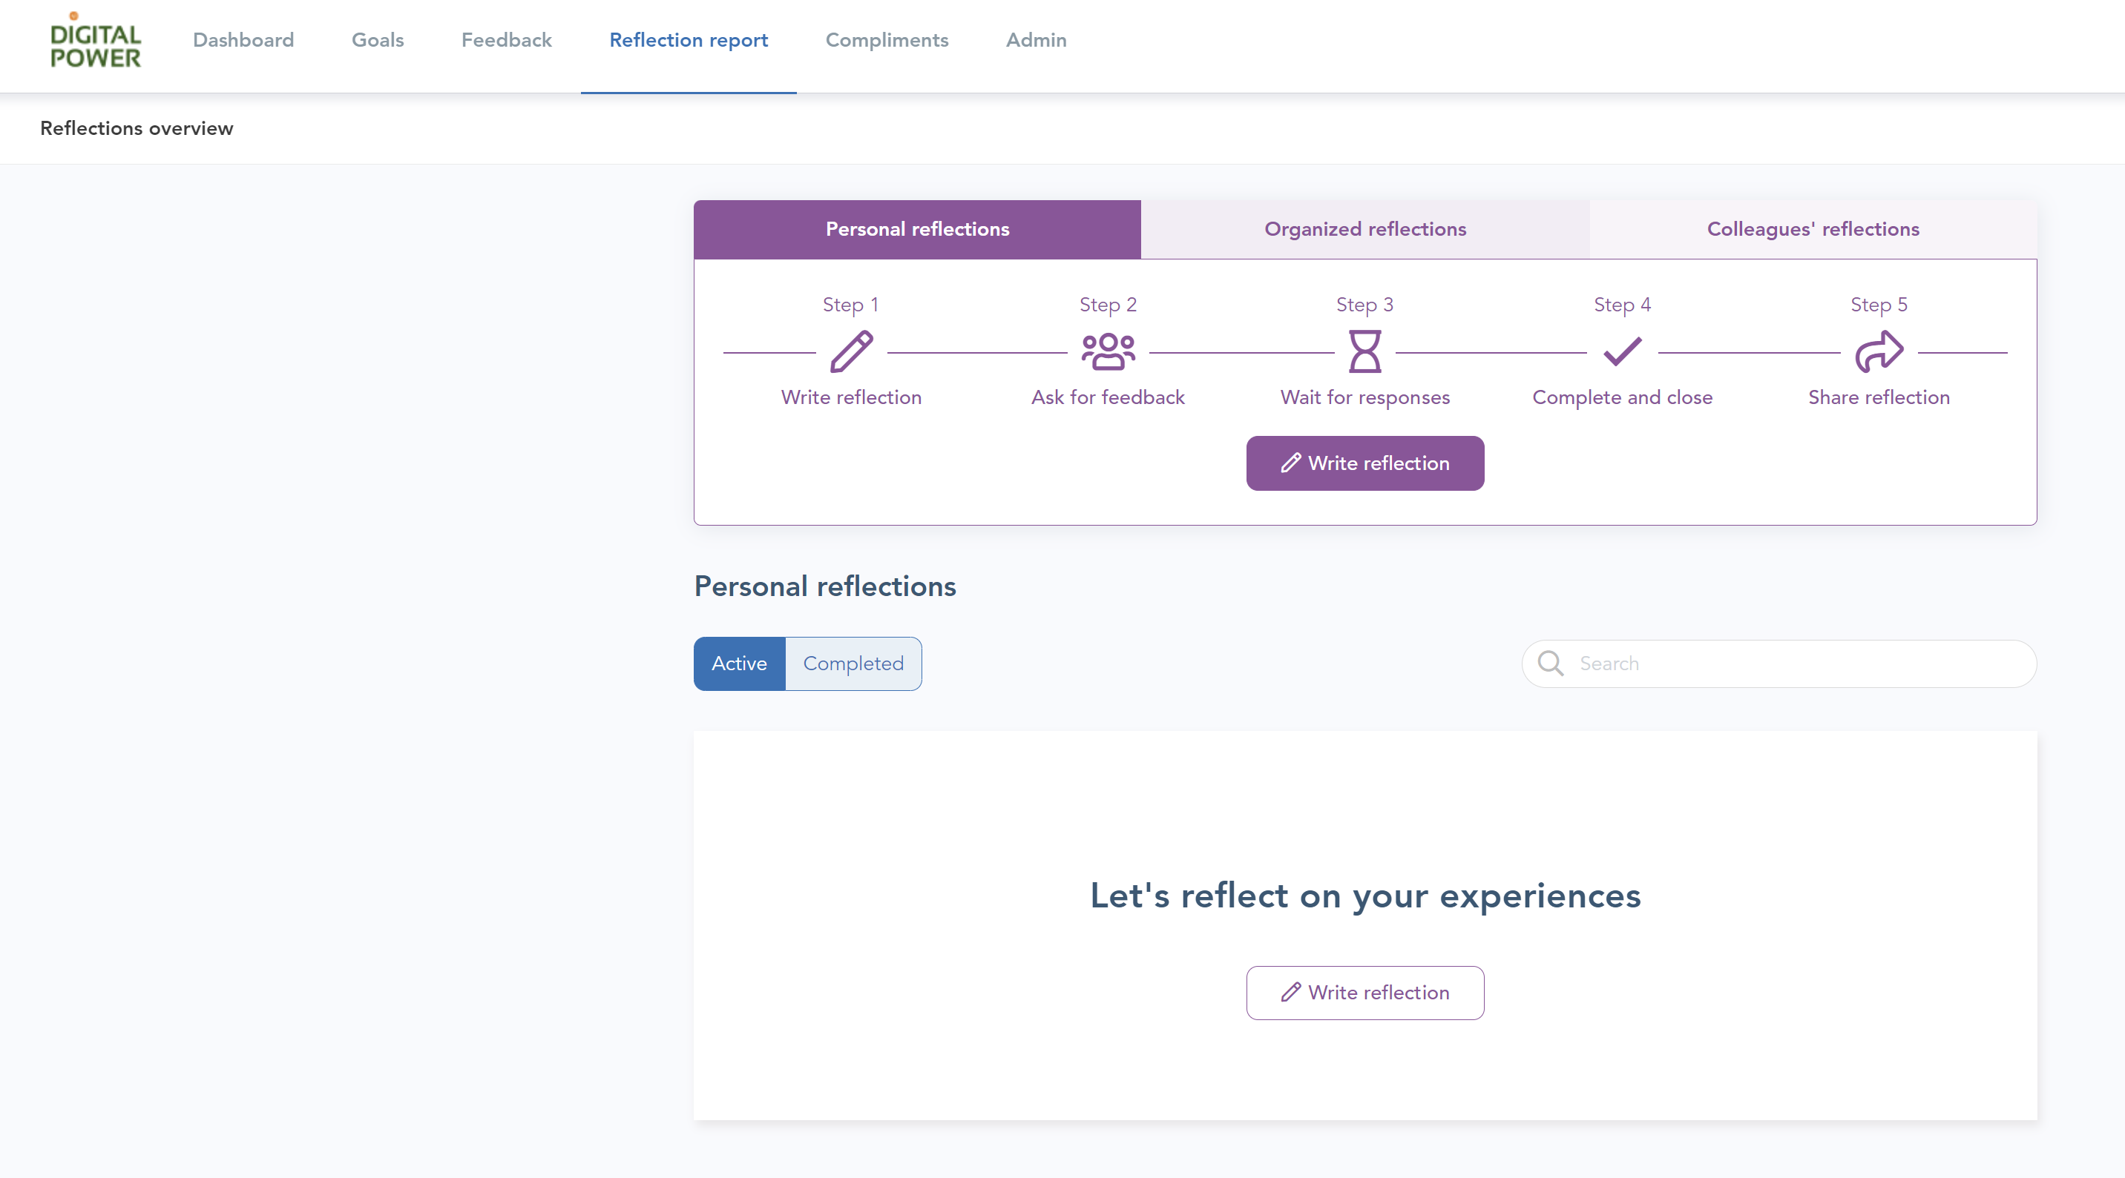

Start your personal reflection. Give your reflection a title and select a period that you want to include in this reflection.
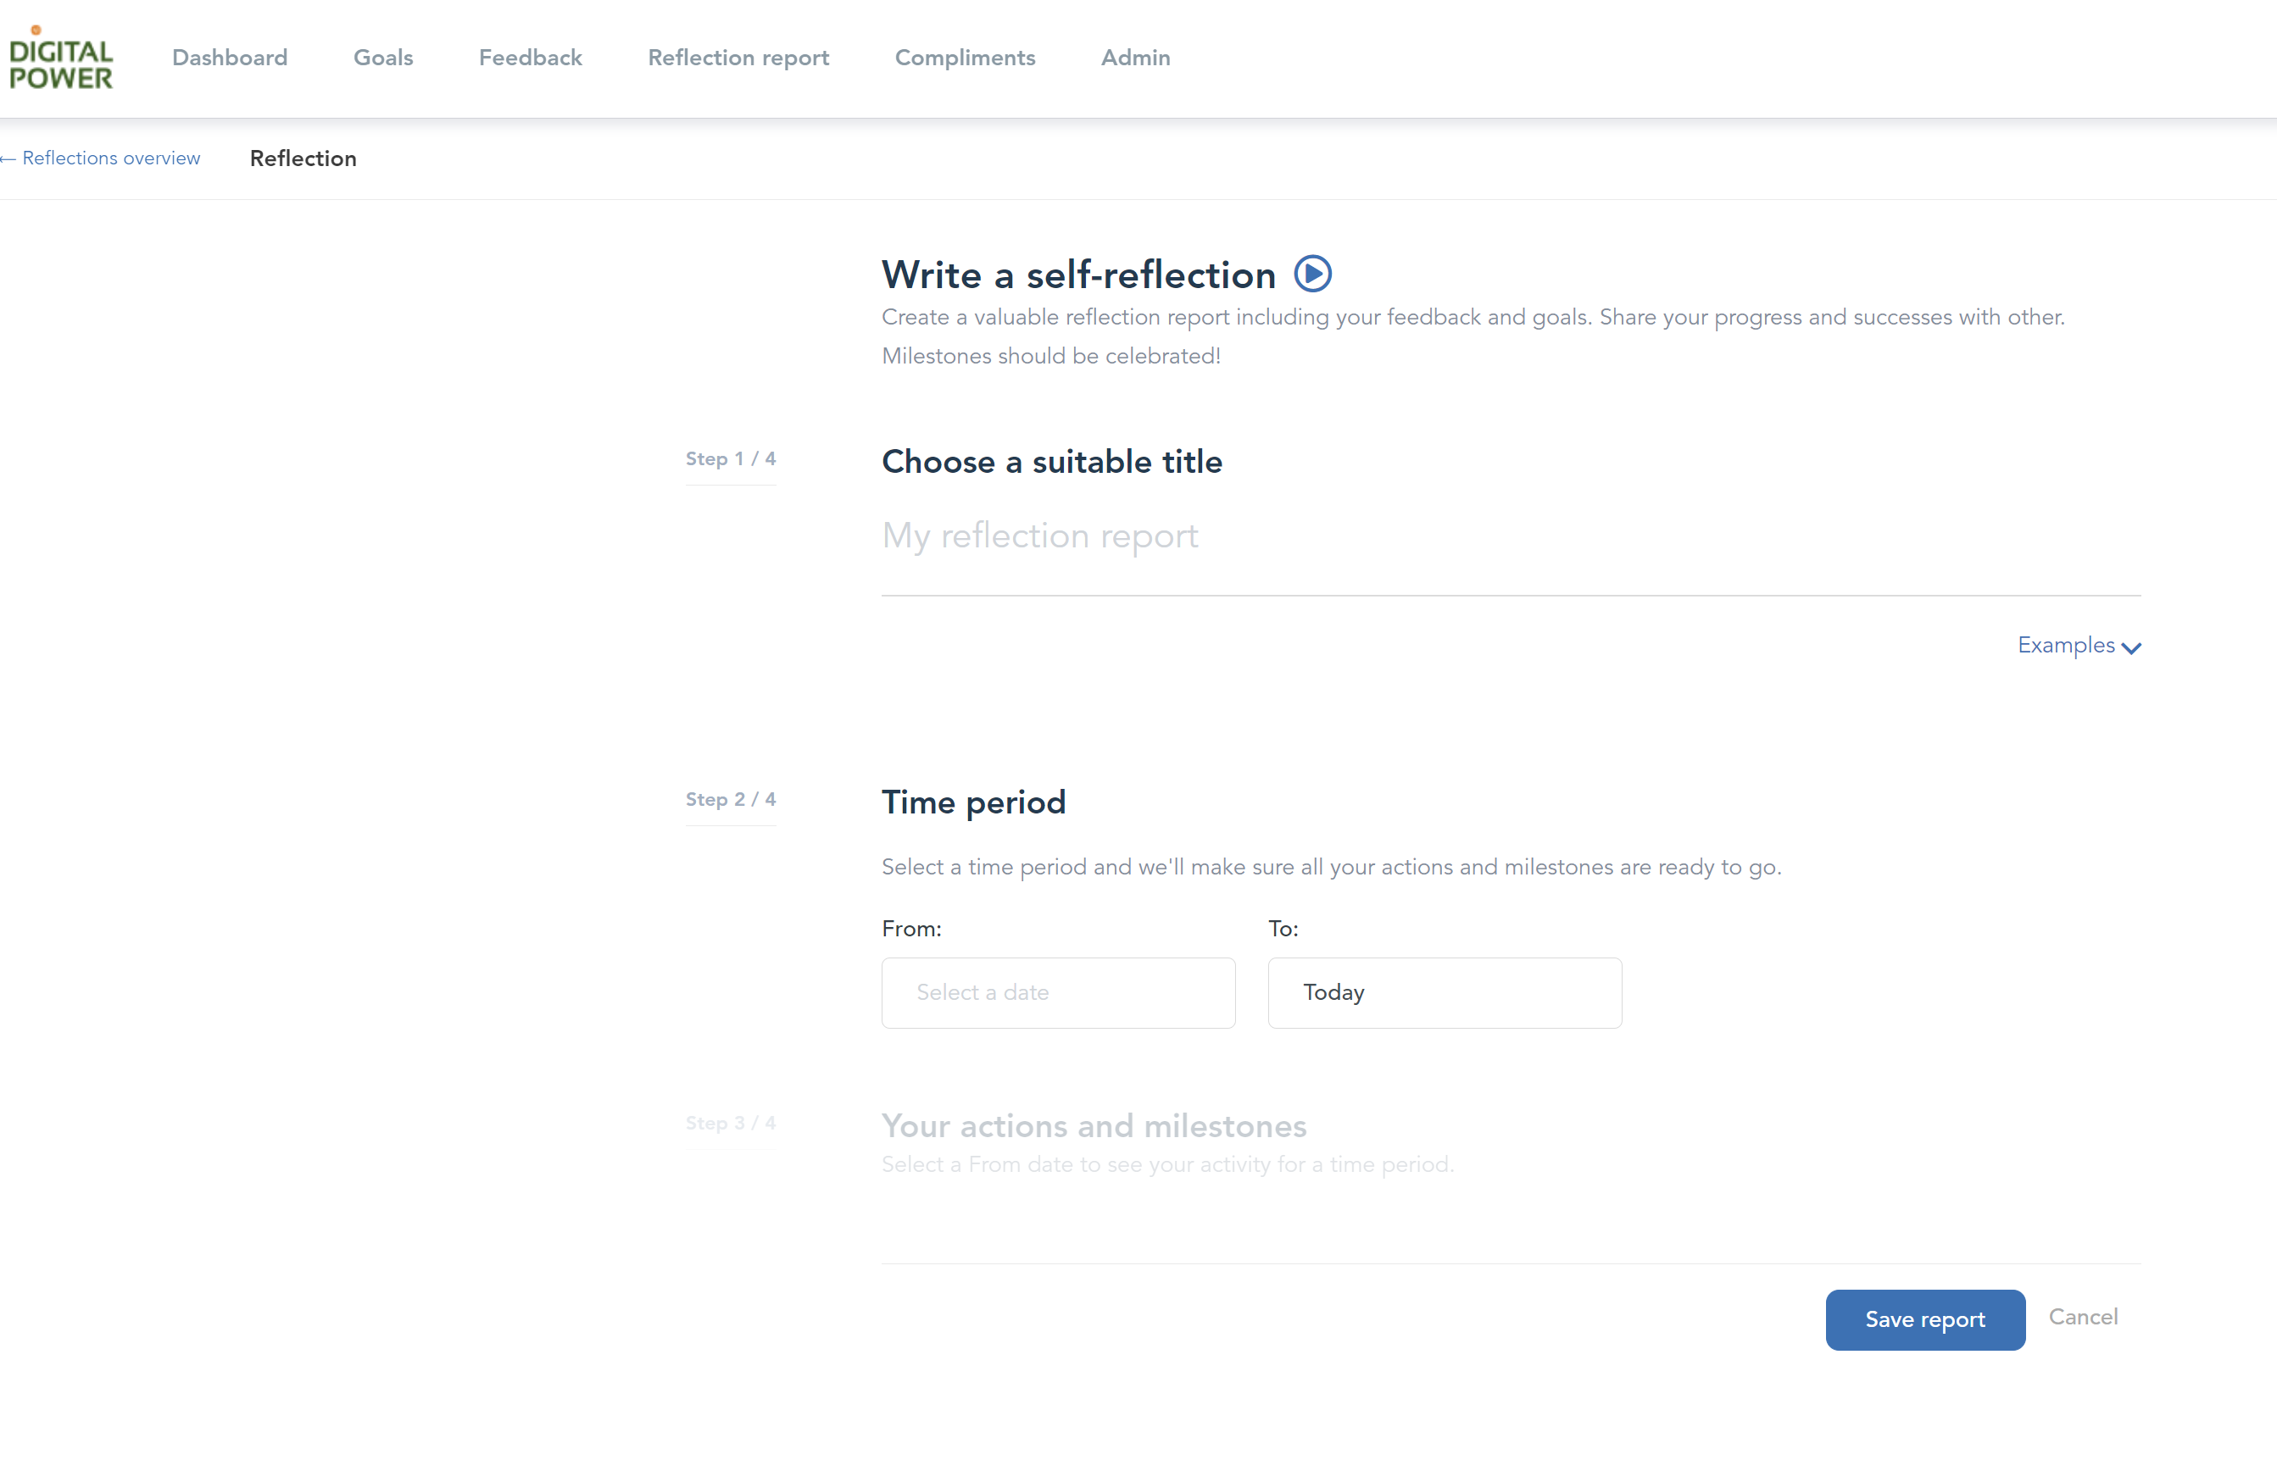

It is possible to add specific actions and milestones to this reflection. You can do so if you want, but it is not needed for your promotion reflection. You can also add people you have received feedback from, this is also optional.
You are now ready to start with the reflection. There is a list of templates available, choose the option: reflection for the next step in seniority (promotion).
You will then be presented with a series of questions that will help you build your case for the promotion committee.

